OS Memory and Memory Management
Module: Architectures, Opera4ng Systems and the Cloud
Module Code: 441102 University of Hull February 26, 2025
Preliminaries
This lab introduces key memory management concepts, including virtual memory, paging, translation lookaside buffers (TLBs), and memory interfacing.
Learning Objectives
- Understand the principles of virtual memory, paging and memory mapping.
- Implement page tables and simulate page faults using C#.
- Explore Translation Lookaside Buffers (TLBs) through coding tasks.
- Simulate memory interfacing concepts.

Software Required:
1. Visual Studio Code (or your preferred IDE) - C#.

Virtual Memory Implementa1on – Paging

- The main memory is divided in fixed-size blocks called Pages
  - Typically each page is 2P : 4KB – 16KB
  - Virtual address : virtual page number + offset bits (32-P, p)
  - Physical address: Physical Page Number + offset
- MMU maps virtual pages to physical pages
  - Uses page map to carry out translation
  - Can cause page faults to occur (a miss) if virtual page is not in physical memory

A simple Page Mapping Design
VM D R PPN PM
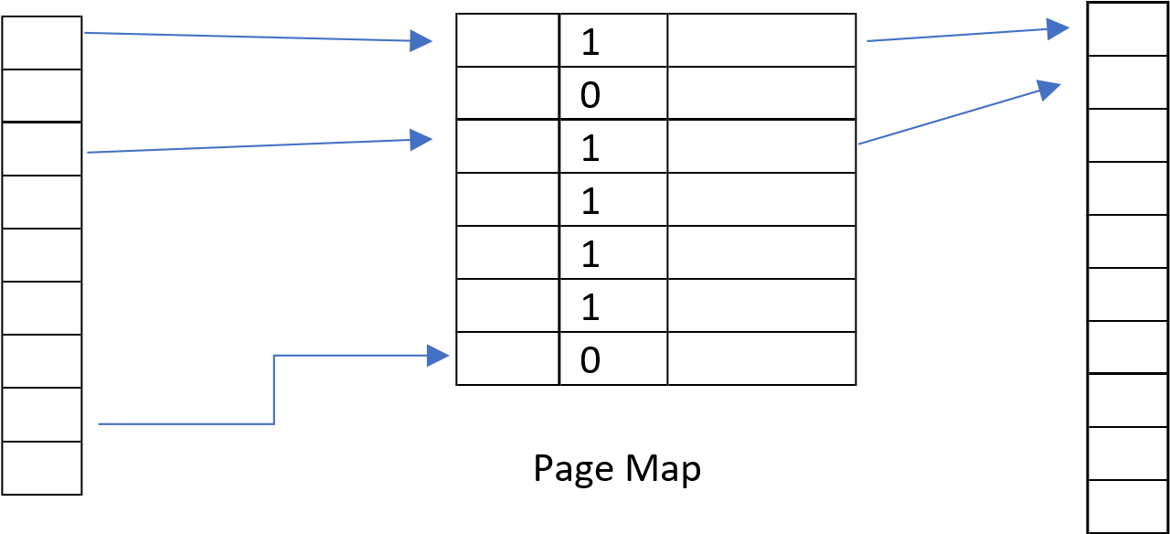

Resident bit R=1 if page is in RAM or 0 for non-resident. Page fault when R=0
PPN = Physical page number for each resident page
Dirty bit D, D=1 if page has changed since loaded from disk

Task 1:
Given the following
Virtual Address
4 bit VPN | 8 bit offset

Physical address
3bit PPN | 8 bit offset

- Determine the number of virtual pages Bytes/page?

Virtual pages = 16 bytes per page = 256

- The following figure shows the 16 virtual pages, and the 8 physical pages.
8 pages

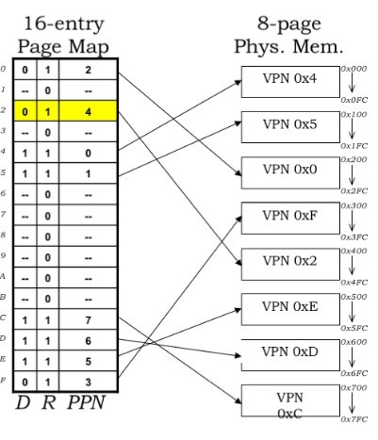
Each row of the page map will have a total of 5 bits (1 each for D&R and 3 bit PPN).
A load instruction is being executed and it generates a virtual address 0x2C8. What is the VPN and offset and the corresponding PPN?

Task 2
The bottom 32K of the main memory is divided into eight page frames of 4KB each. In the table the first column represents the Page frame, the second column give the range of Physical addresses..
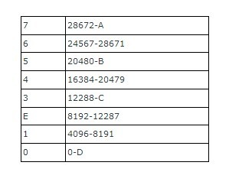
Determine the values of A, B, C, and D
A = 32767
B = 24575
C = 16383
D = 4095
Task 3:
The table below shows the page table with the first 8 entries of a table . A 32 bit virtual address is shown in table below.

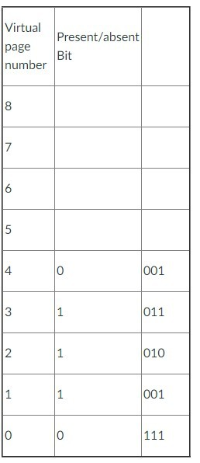

Table: 32 bit virtual address (first 20 bits represent the page and the next 12 bits the offset)

2.a What is the virtual page that is referenced?
0
2.b The page frame value (in both binary and denary)
Binary = 111 dinery = 7
2.c What is the construct the physical address with the information given
Page fault

Task 4: Translation Lookaside Buffers (TLB)
Task 4.1
A particular computer system has a virtual memory of 232 bytes, and physical memory of 224 bytes. The page size is 210 Bytes (1 KB). It has a 4 entry TLB. VPN is 22 bits, offset is 10 bits, and PPN is 14 bits.

- How many pages reside in the physical memory at one time?
16384
- How many entries are there in the page entry?
4,194,304
- How many bits per entry in page table?
15
- How many pages does the page table occupy?
7680

Translation Lookaside Buffer (TLB) Simulation
- Simulate TLB hits and misses.
- Track the hit ratio after a sequence of address translations
EXAMPLE:
using System.Collections.Generic;
class TLBEntry { public int VPN;
public int PPN;
}
class TLB { private List<TLBEntry> entries = new List<TLBEntry>(); private const int capacity = 4; // TLB capacity
public int? Lookup(int vpn) { foreach (var entry in entries) { if
(entry.VPN == vpn) return entry.PPN;
} return null; // TLB miss
}
public void Insert(int vpn, int ppn) { if (entries.Count >= capacity)
entries.RemoveAt(0); entries.Add(new TLBEntry { VPN = vpn, PPN = ppn }); }
}
Tip!
Add a screenshot of your solution to your portfolio, explaining what you are doing.

I added the virtual addresses with the memory accesses. Then I track how many times a entry is found using “int hits” and “int total” then each memory address gets gone through one by one. Inside the loop I removed the offset by shifting getting rid of 12 bits then check if it’s a hit or miss if it’s a hit +1 to hits if it else it’s a miss. Then I calculate the ratio and print it.

Task 4.2 (Bonus task)
Given the following information

What is the physical address for the virtual address 0x1804? Explain the process used by the MMU to determine the physical address.
What happens when a virtual address 0x0FC is generated?

Hint: decompose the VA into VPN and Offset. In this case the lower 10 bits (also know as lower order) is the offset. The VPN is the remaining address bits. For this you will need to use different number conventions to move back and forth

Task 5: Memory interface
Below diagram shows a memory block and the contents stored.
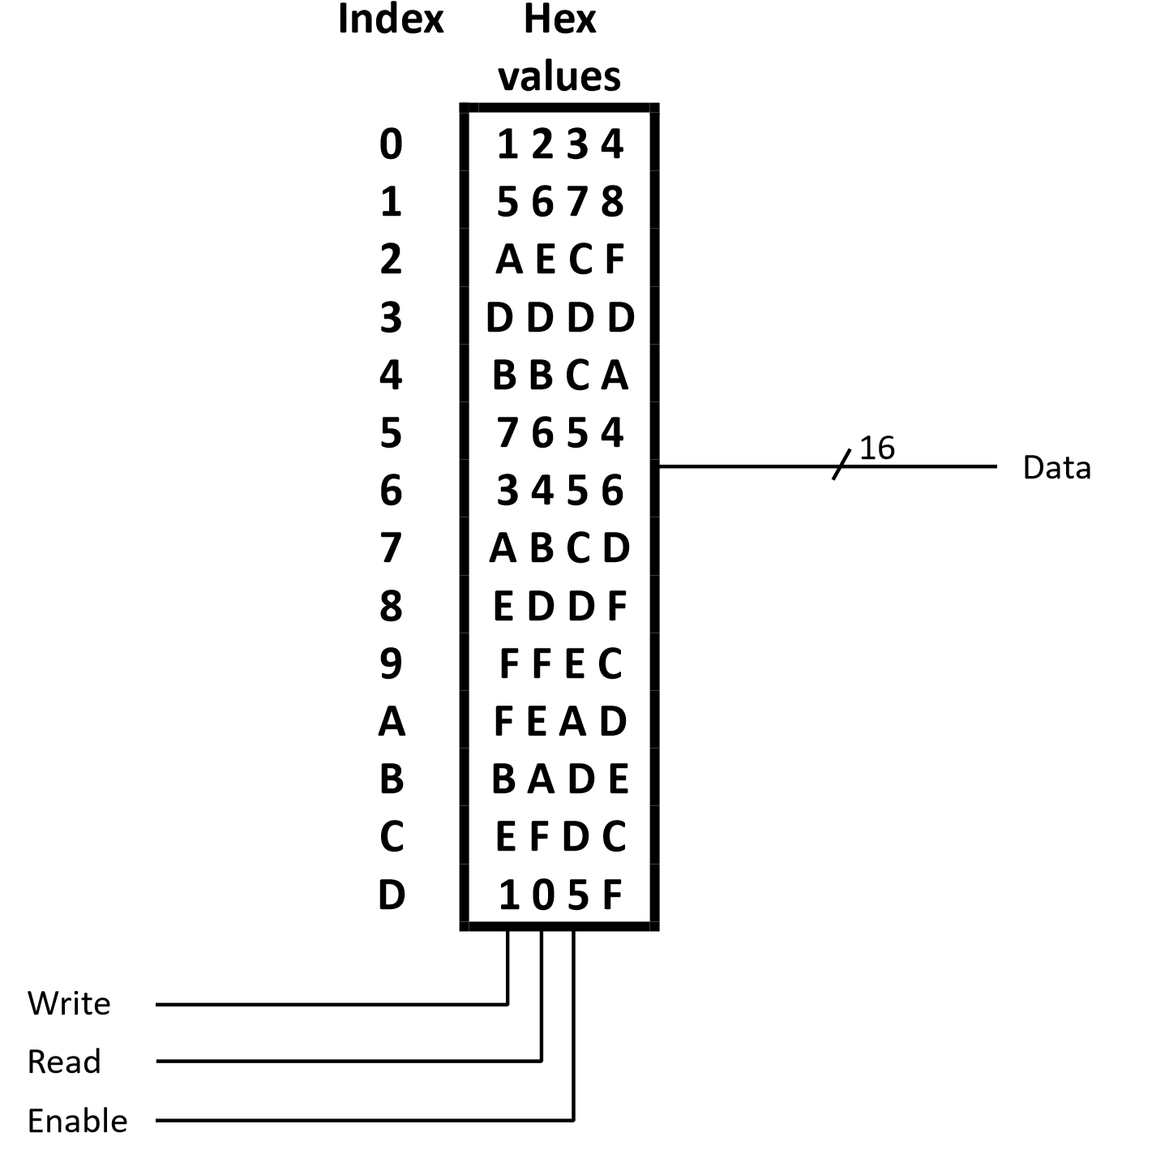

Task 5.1
Use a decode to interface this memory to a processor. Think about how many input bits will be required by the decode to index all memory space. Draw the diagram accordingly.
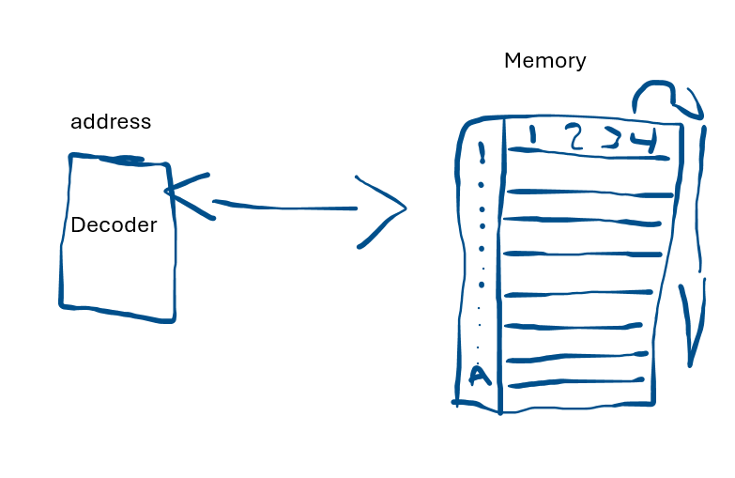

Task 5.2
If we add the control bits as part of the memory address, then the memory address not only have the actual address of the memory, but also contains the control bits. For example, if we have below pattern with a 2 to 4 decoder,

Write Read Enable Decoder
Then we will have 5 bit address to locate the 4 positions of the memory. Therefore an address value of 10101 (this is 0x15 in hex – the 0x prefix is another way to indicate the “15” is a hex number similar to 1516) will trigger a write action to memory location with index 1.

Use similar combined address patterns, and work out the address value to a.
read memory location with content FEAD
A = 1010 write = 0 read = 1 enable = 1
10111010

b. write to memory location with its index value as C
c= 1100 Write = 1, Read = 0, Enable = 1
1011100

